Final project

FPGA based Digital Design

Omri Raz – 318671120

Eyal Rothschild – 318793882

**Introduction:**

**Aim of the Assignment:**

• Design, synthesis, and analysis of a simple (single cycle architecture) MIPS CPU core with Memory Mapped I/O, interrupt capability, basic timer and FIR filter.

• Understanding of CPU vs. MCU concepts, and FPGA embedded memory structures.

**The system:**

In this project we were asked to build MCU that contains a Single Cycle MIPS with data memory DTCM and program memory ITCM for hosting the program data and code segments. The MIPS will handle interrupts.  
In addition the MCU contains peripheral components such as: switches , LEDS , FIR filter etc.

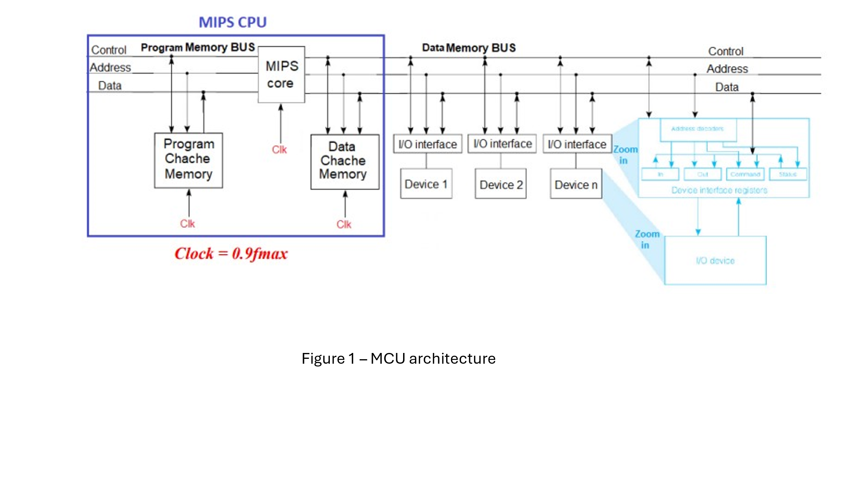

**GPIO:**

• The GPIO (General Purpose I/O) is a simple decoder with buffer registers mapped to data address (Higher than data memory) as given in the assembly code examples that enables the CPU to output data to GPIO devices as LEDs and 7-Segment and to read the Switches array value.

**I/O devices and memory mapped I/O:**

• Board eight switches (SW7-SW0) and push four debounced pushbuttons (KEY3-

KEY0) will be used as Input interface.

• Board 8 red LEDs (LEDR7-LEDR0) and six 7-segment displays (HEX5-HEX0)

used as Output interface.

• Connections between the 2x20 GPIO Expansion Header and Cyclone V SoC FPGA

In the next figure we can see how the data address space.

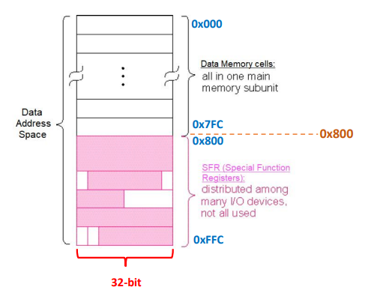

The Data Address Space is 32-bit WORD aligned where the physical address space it is the lowest 12-bit 𝟎 … 𝟎𝑨𝟏𝟏 … 𝑨𝟎 with partial mapping.

In the next figure we can see how the I/O devices are connected to the buses.

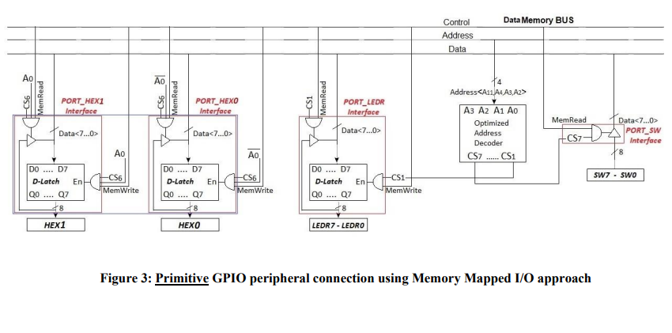

We were asked to implement the GPIO peripherals.  
In the next figures we will see examples of the implementation:

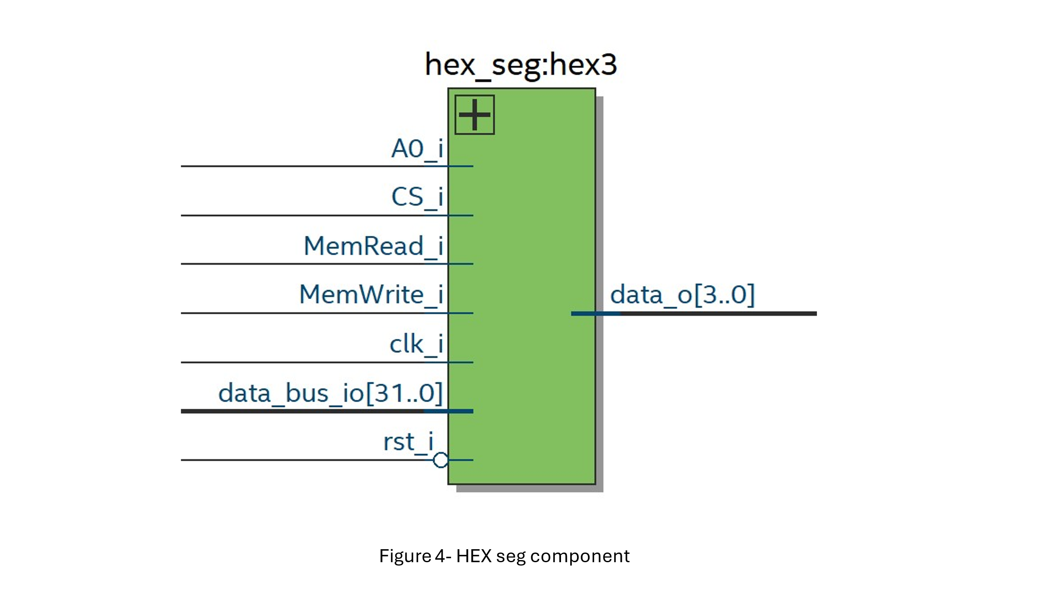

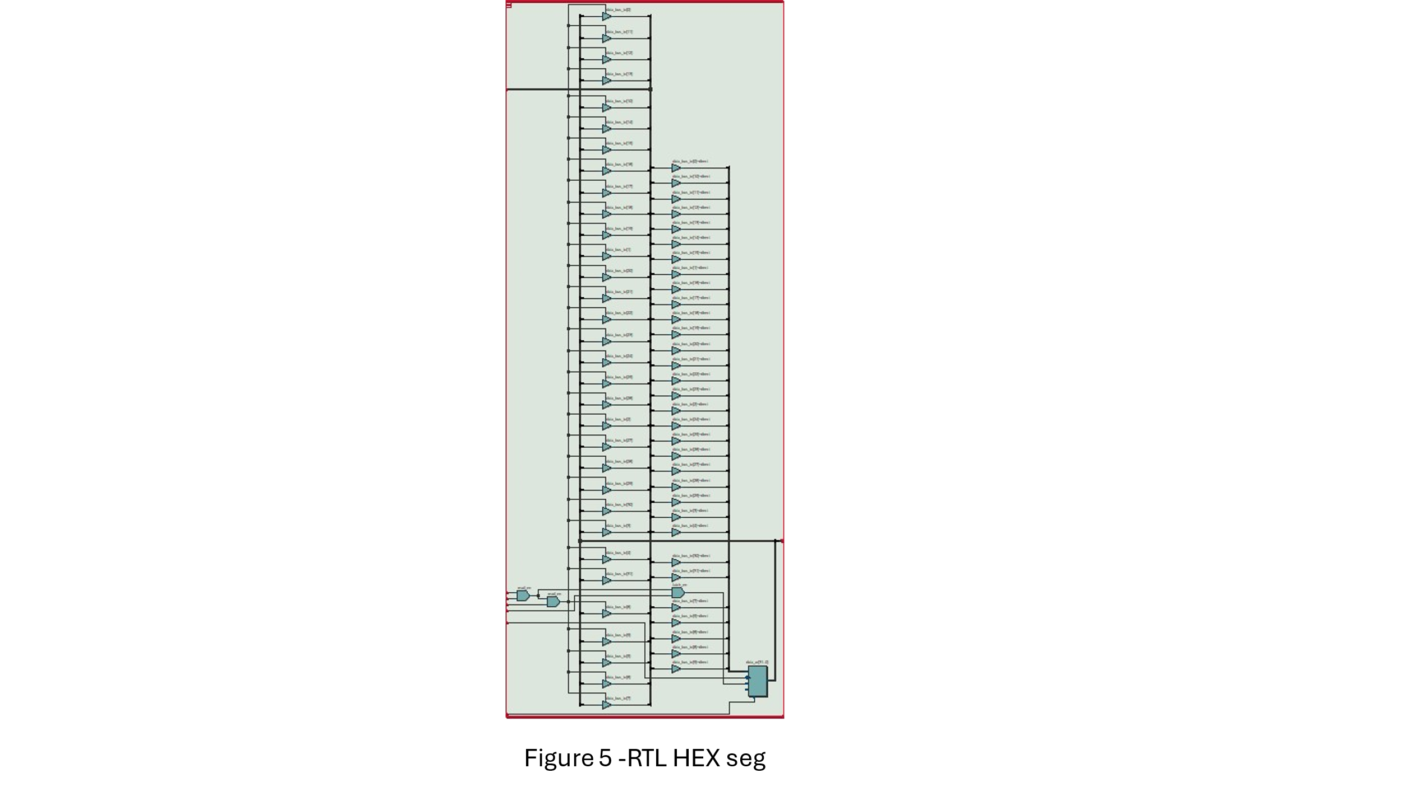  
in figure 4 and 5 you can see how we have implemented the connection of one of our I/O devices to the busses.

Each component got the relevant Chip Select, Adress, MemRead_i, MemWrite_i bits to decide on the read and write from the component in order from avoid from collision of data.  
Another example is of the switches:  
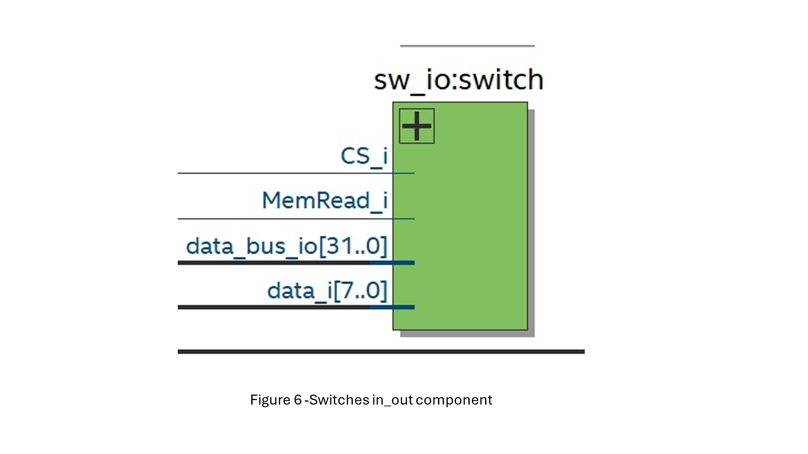

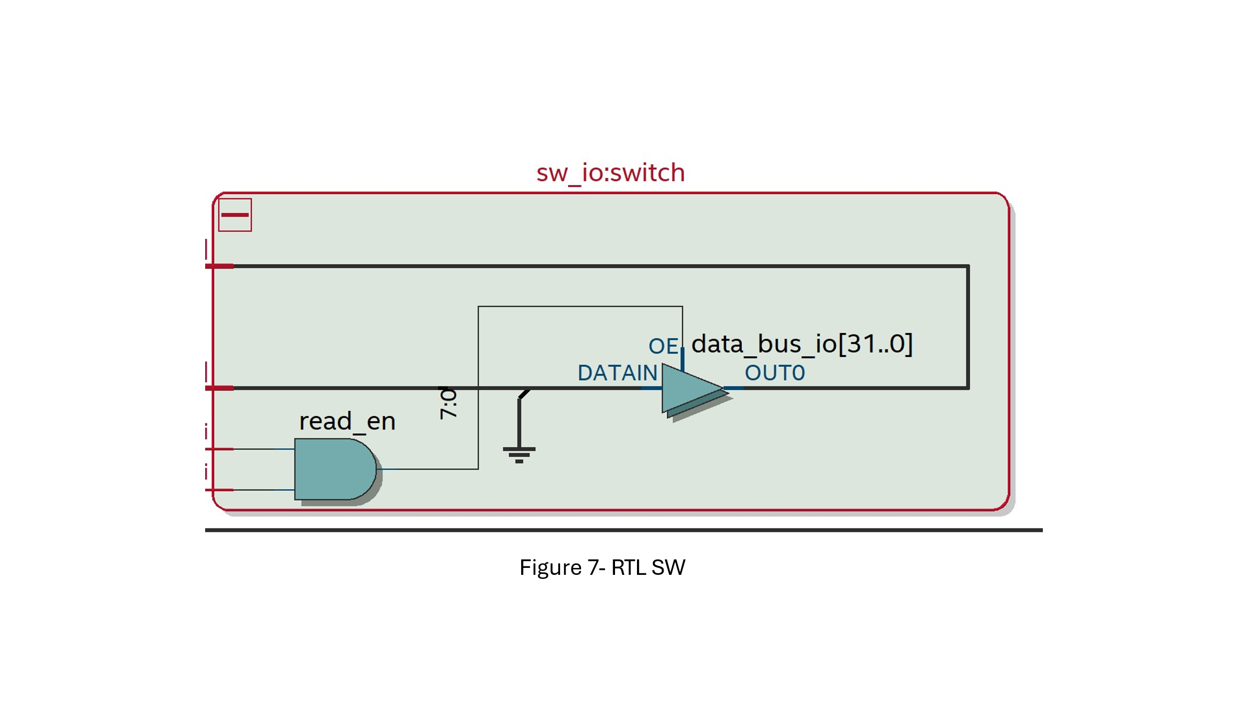

**MIPS:**

This is the CPU of our system. We have decided to use a single cycle architecture.

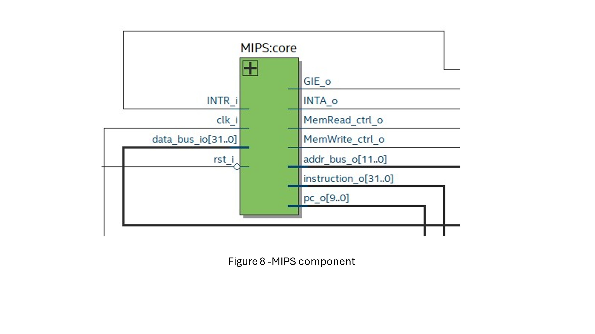

Here we can see all the signals that enter and exit the MIPS component.

We have added INTR and INTA signals to handling interrupts.

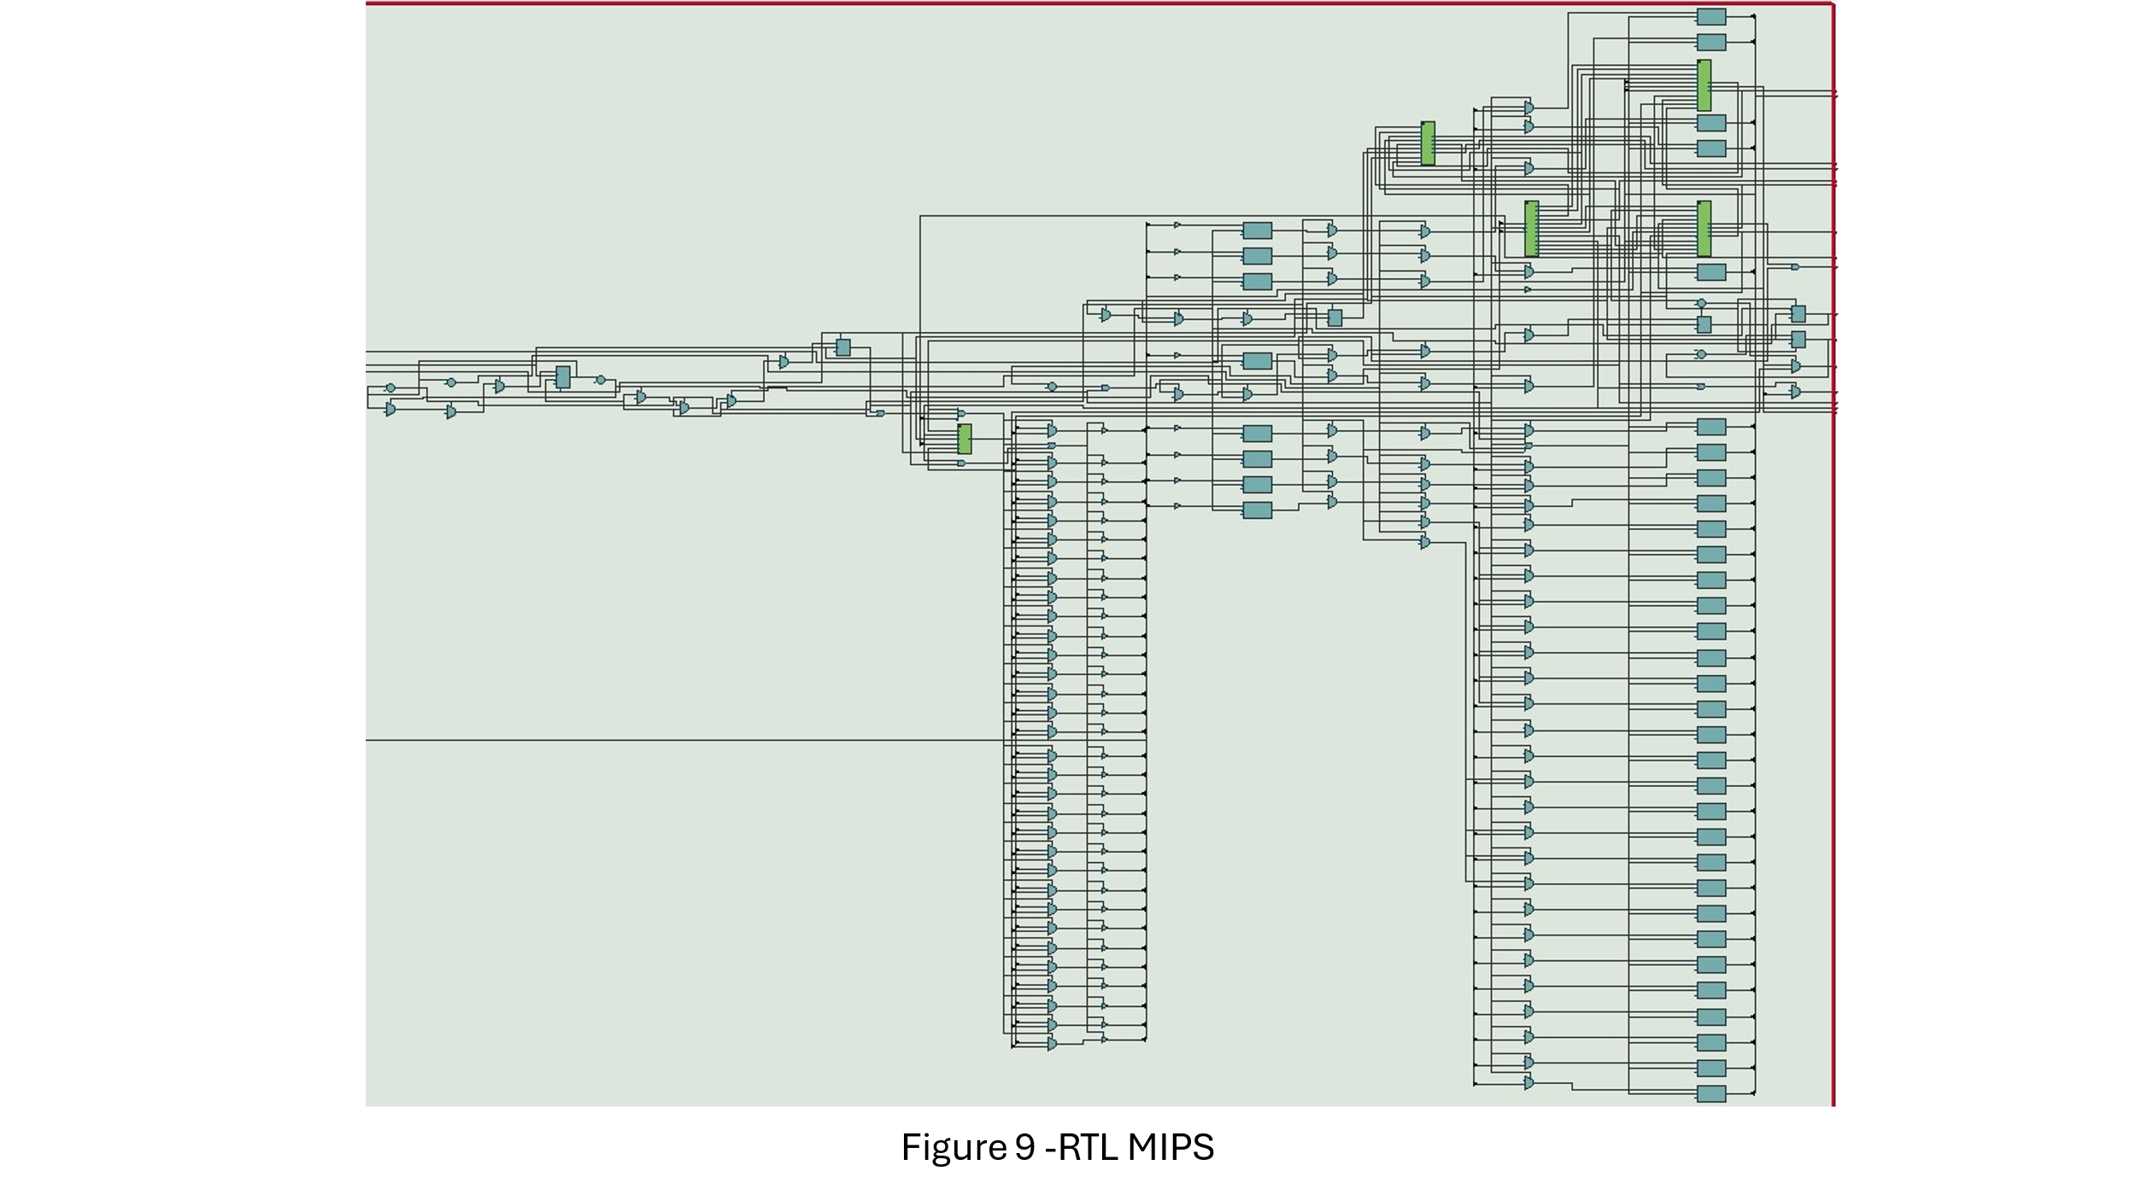

And here we can impress from our RTL of the MIPS.

**Basic Timer:**

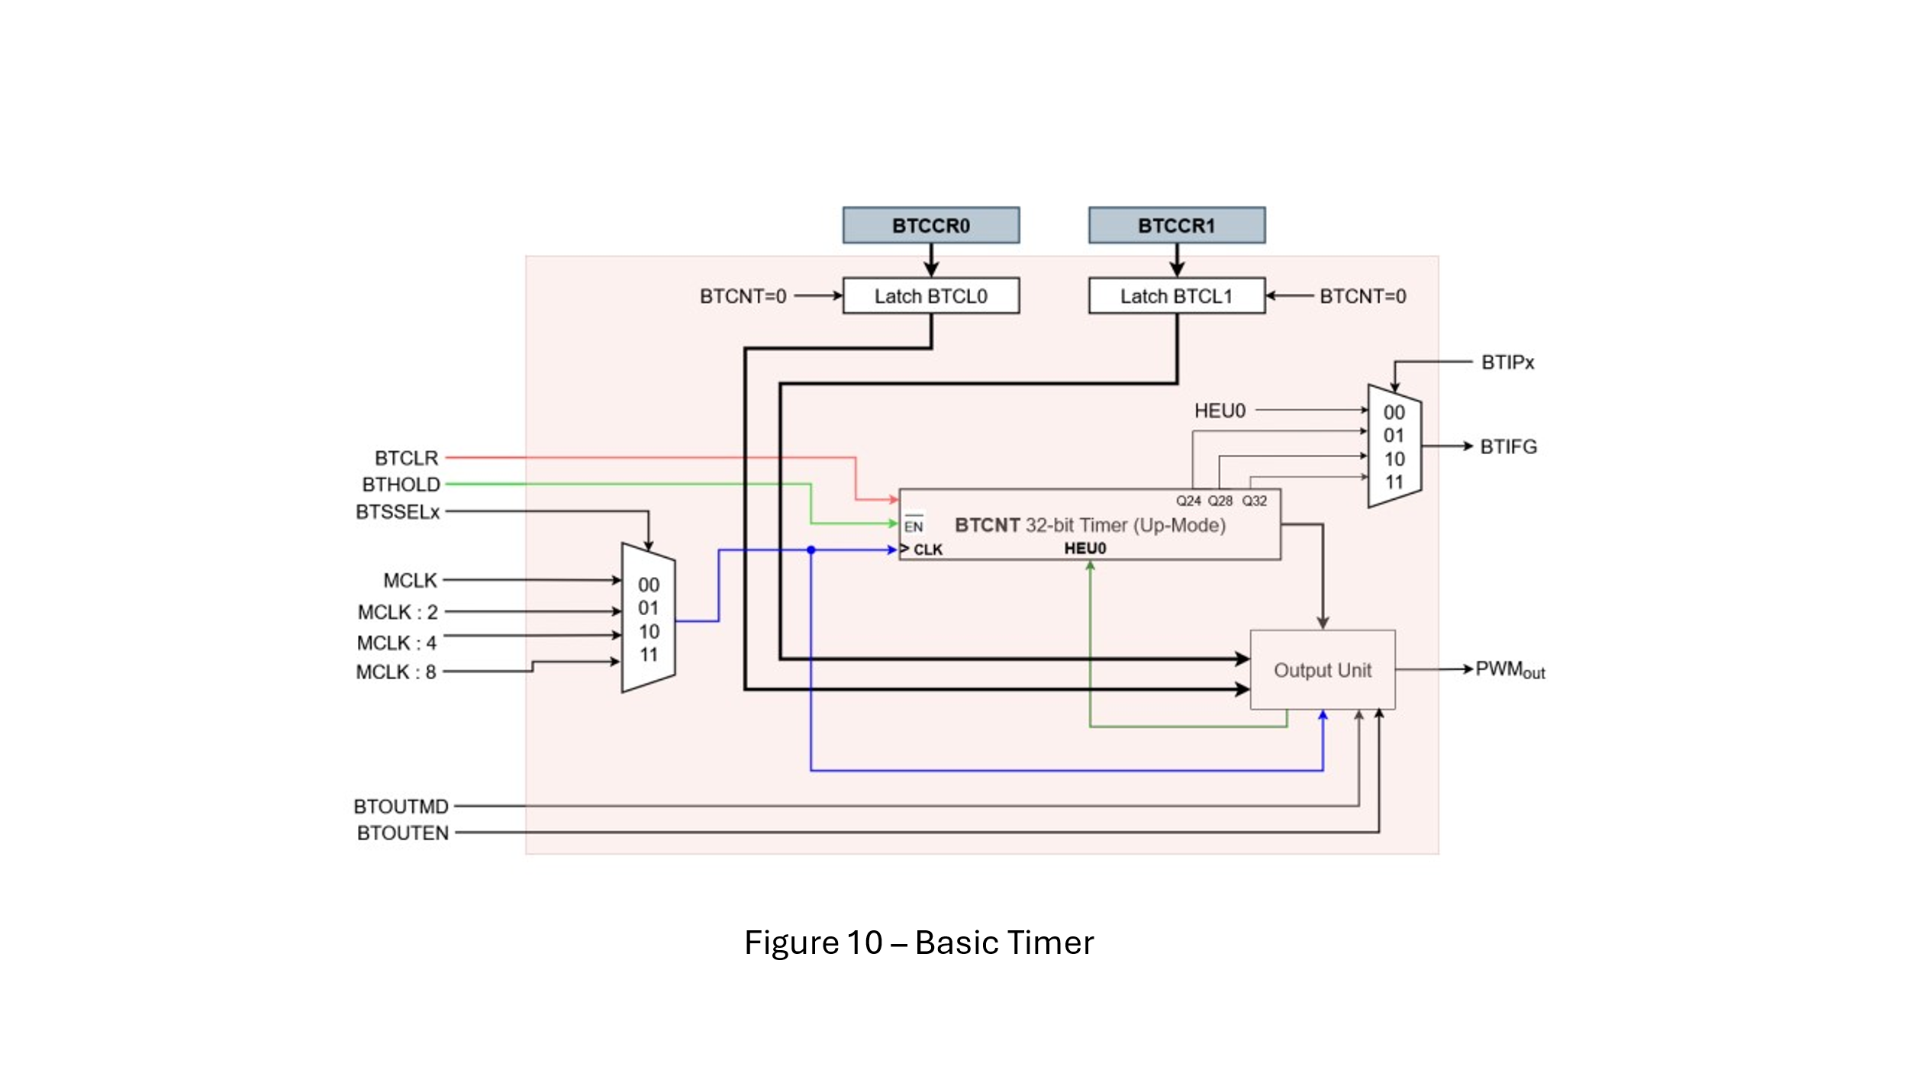

This component is a basic timer, it has the timer counter, the output unit (for creating PWM output), 4 clocks that are chosen by the BTSSELx , 2 registers – BTCCR0 and BTCCR1 who are memory mapped I/O and BTIFG signal that create an interrupt.

In the next figures, we will see how we have implemented the Basic Timer.

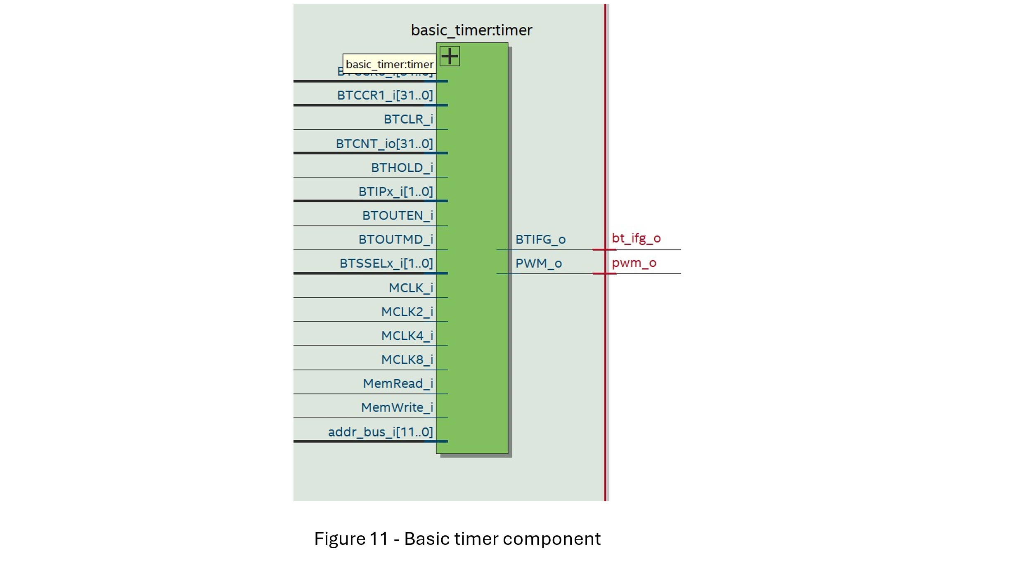

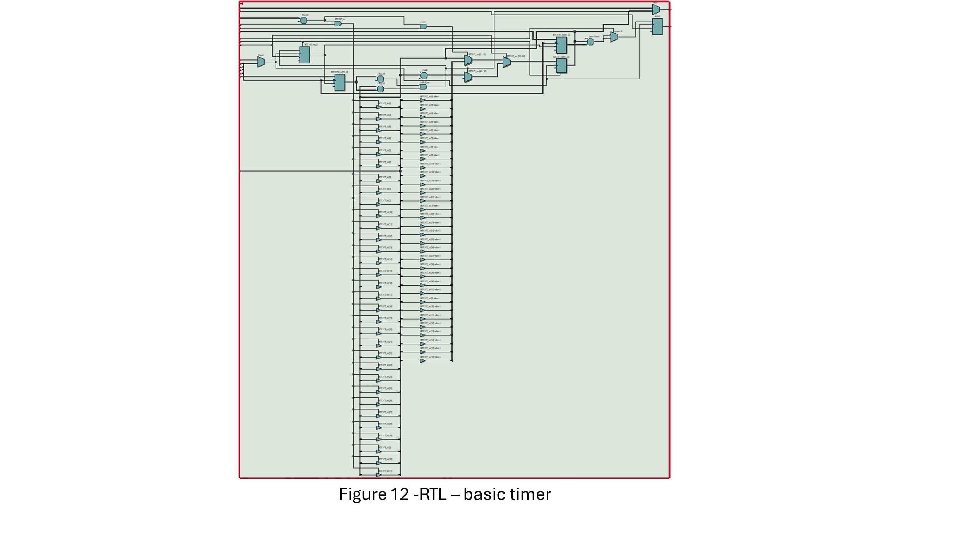

**FIR:**

we have been asked to implement a HW- Accelerator - FIR:  
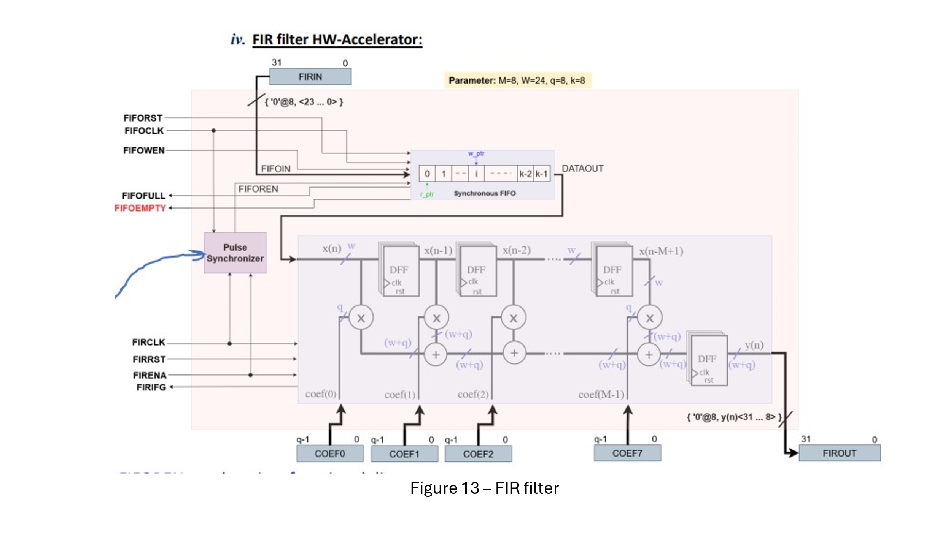

we have implemented this component with FIR top and FIR sub-component:  
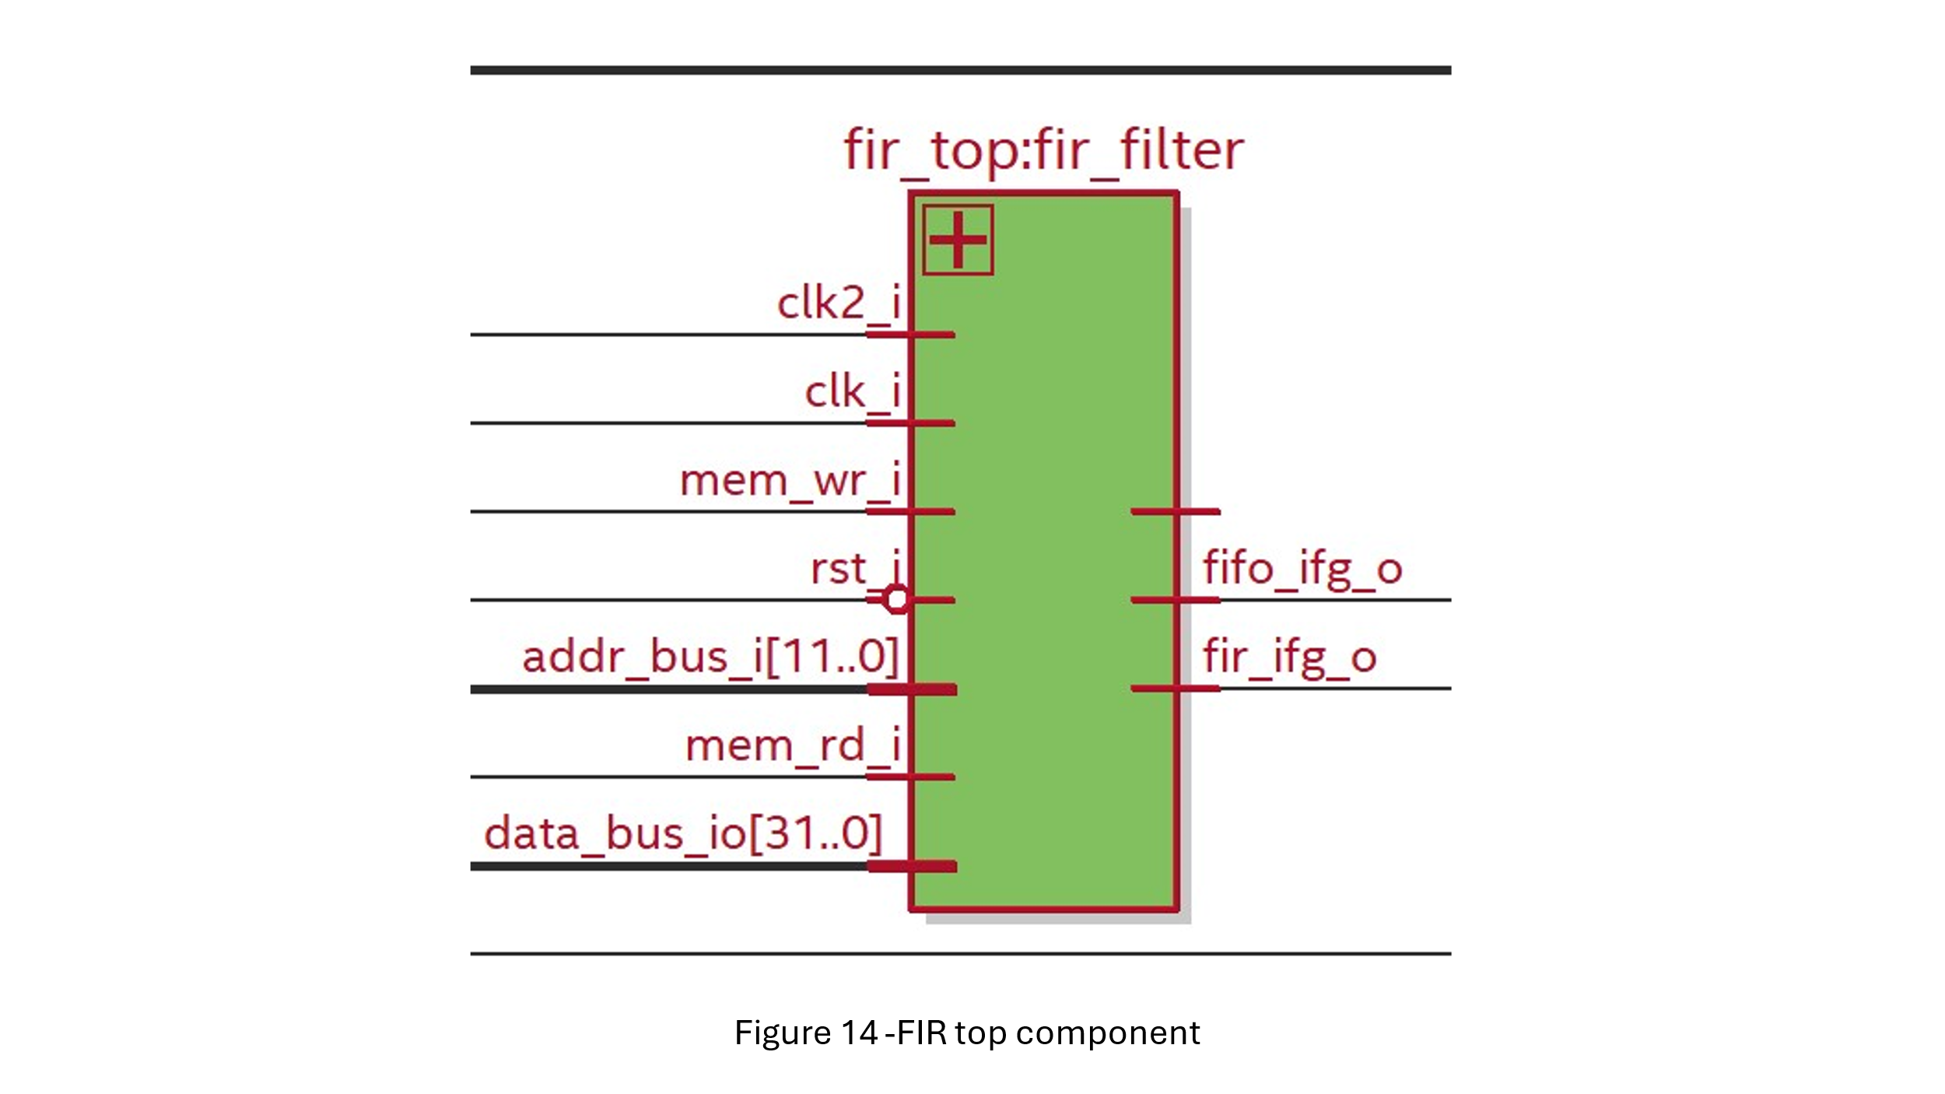

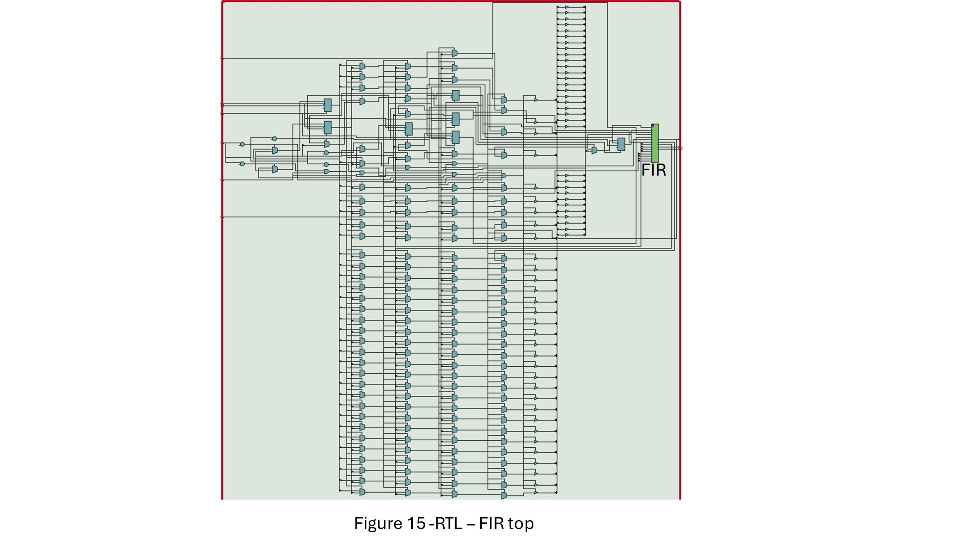

Than we create a FIR component that contains several subcomponents :

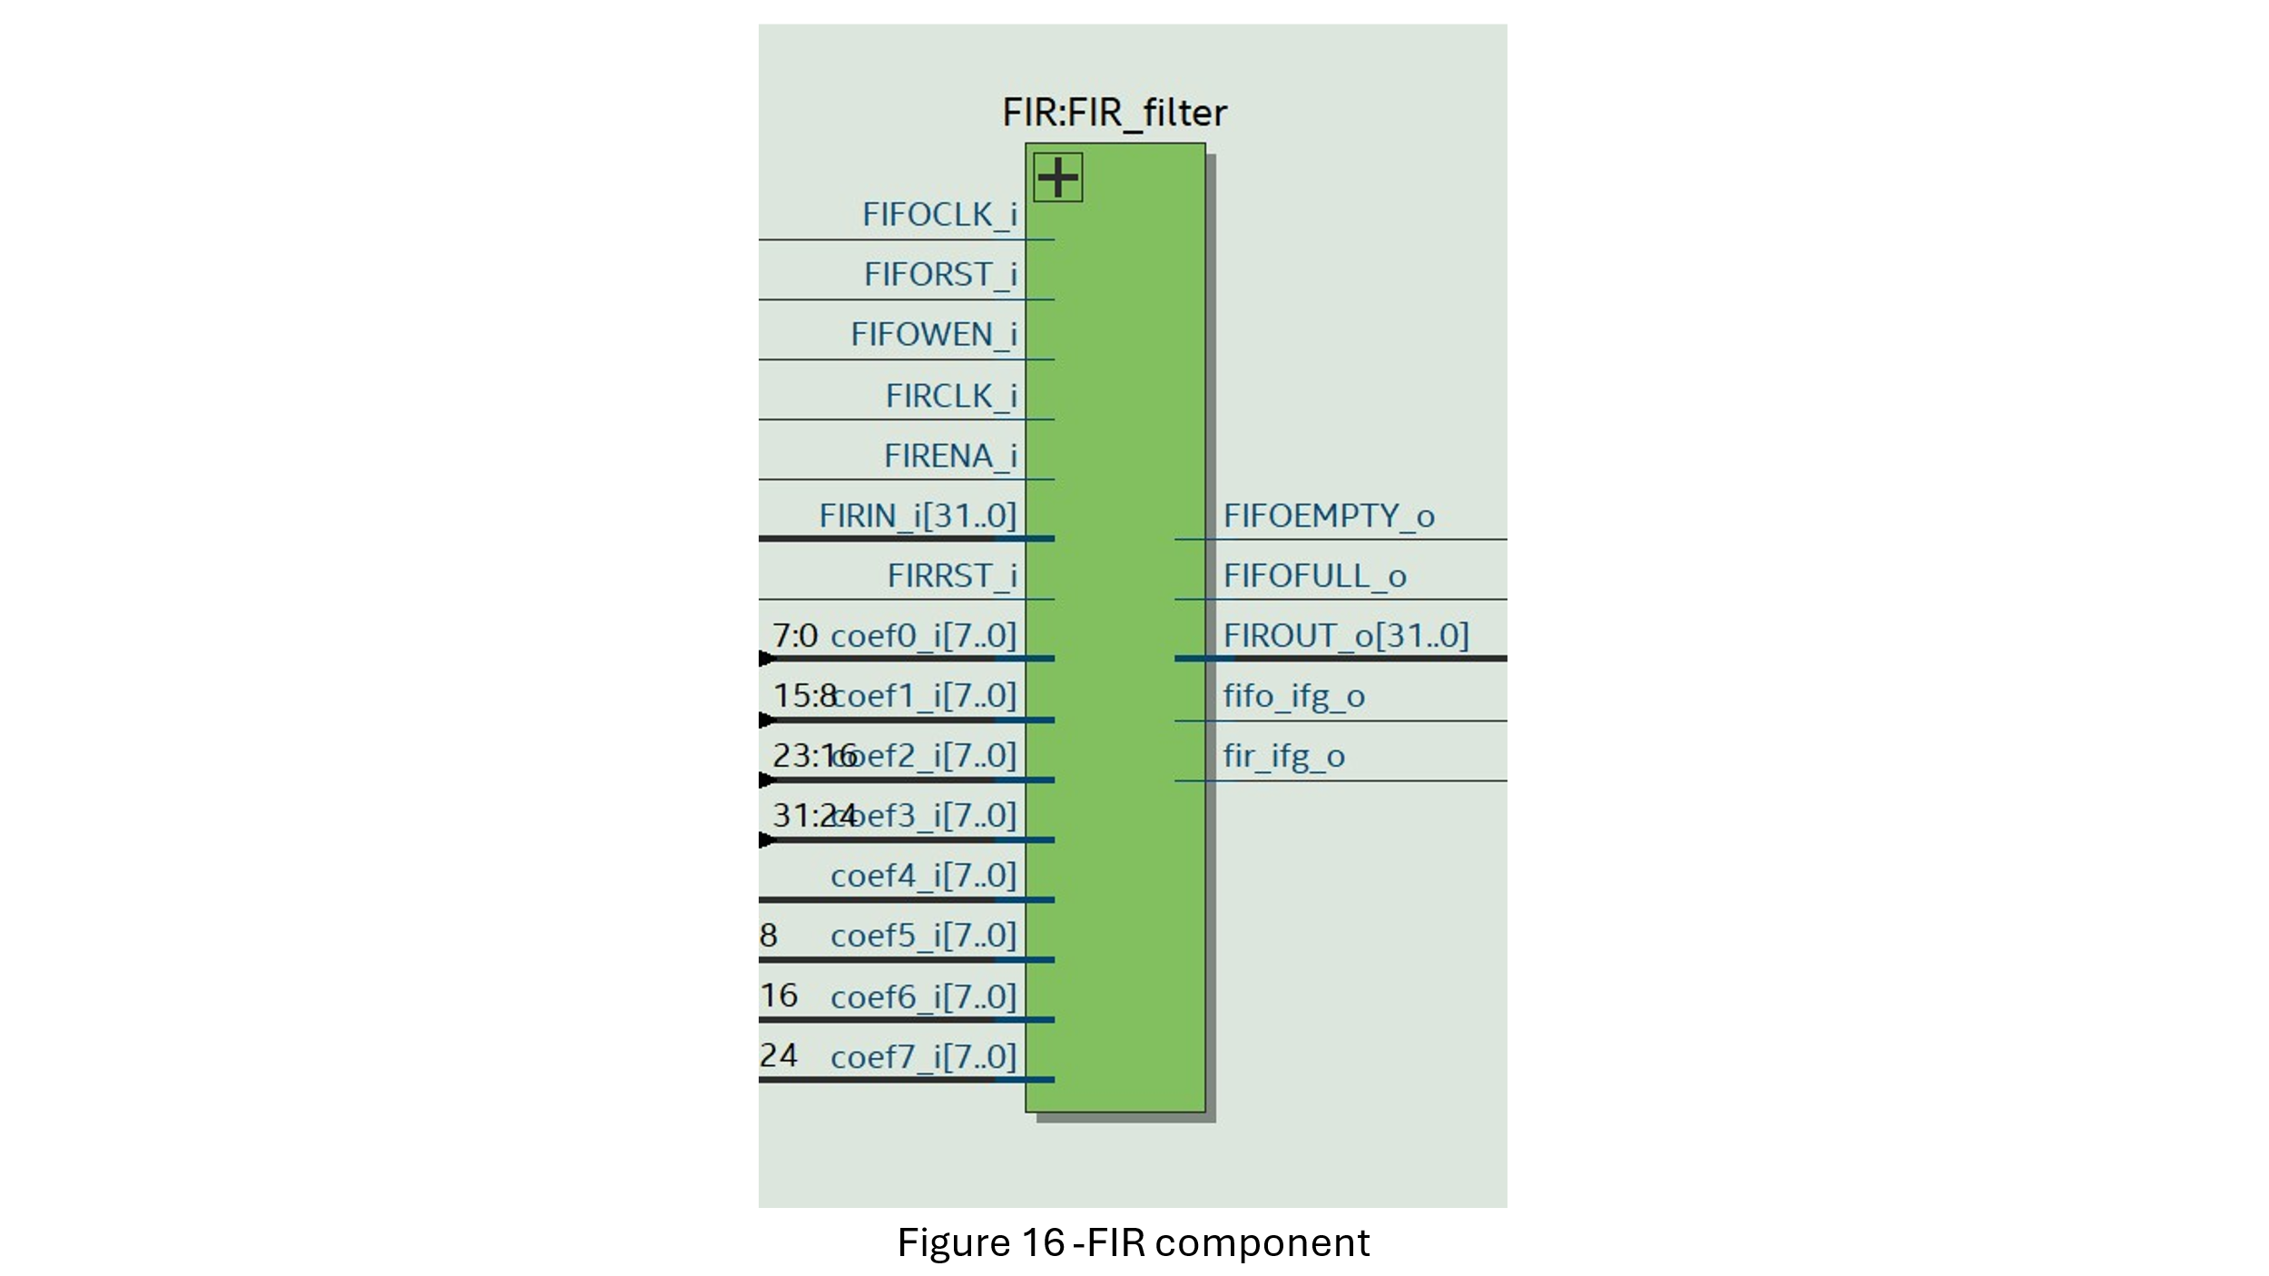

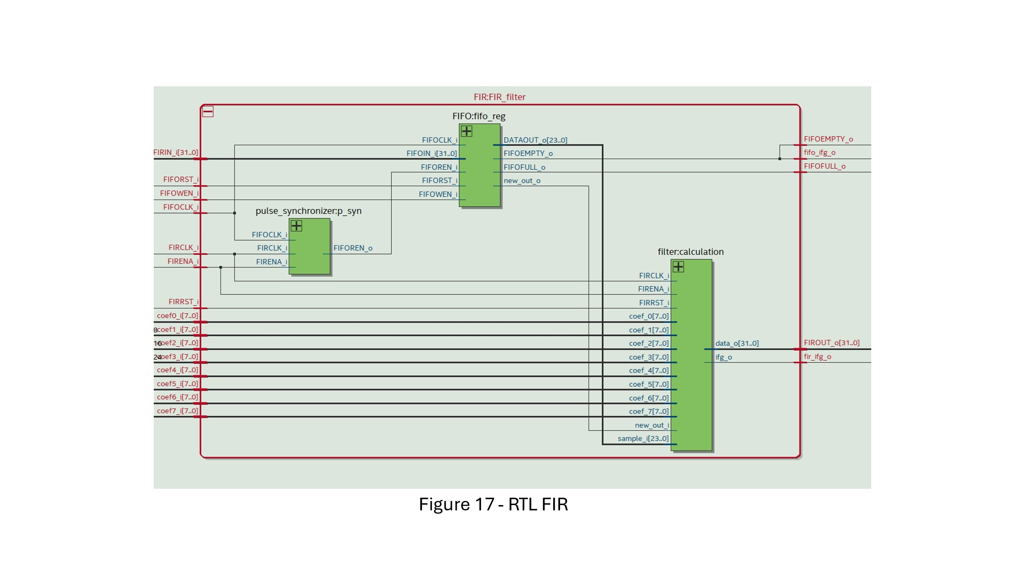

Our subcomponents are the pulse synchronizer, the FIFO register and FIR calculation:  
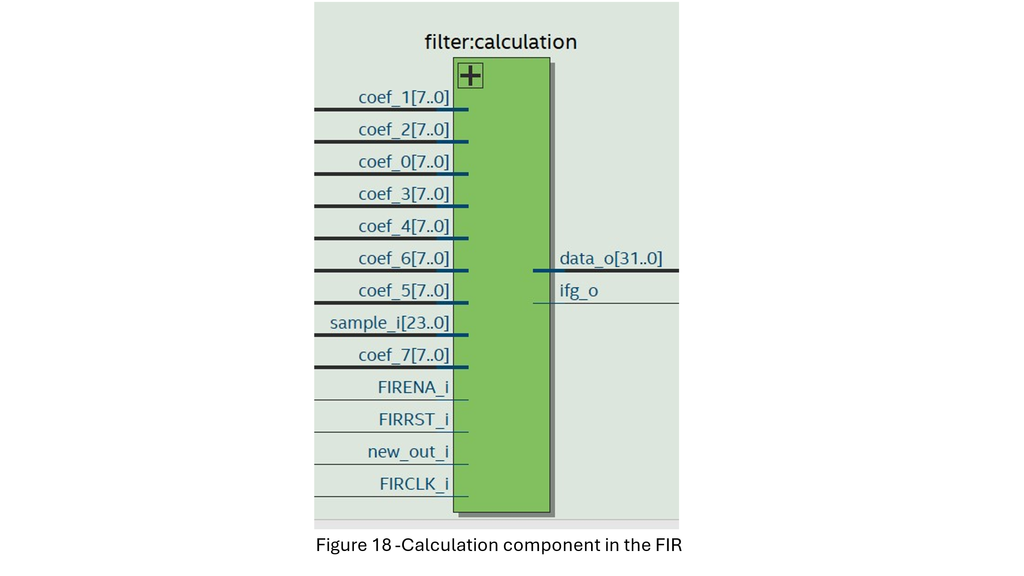

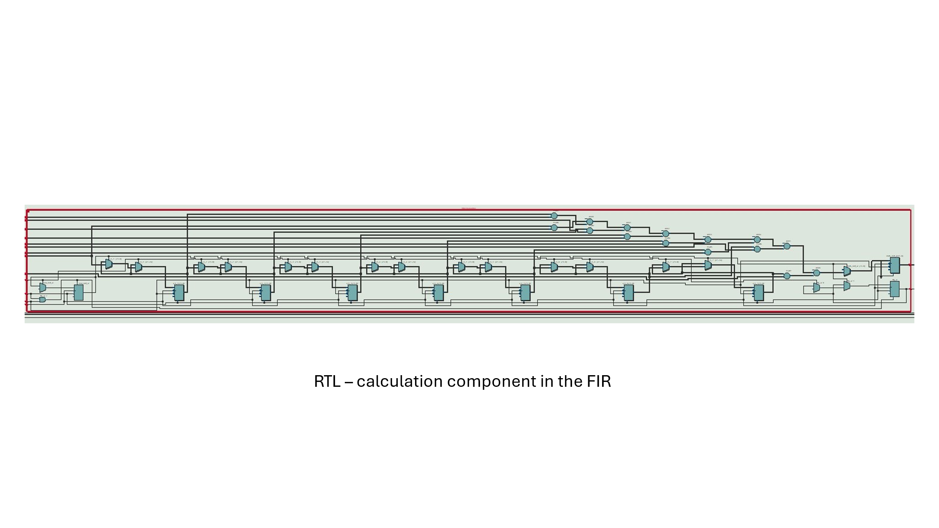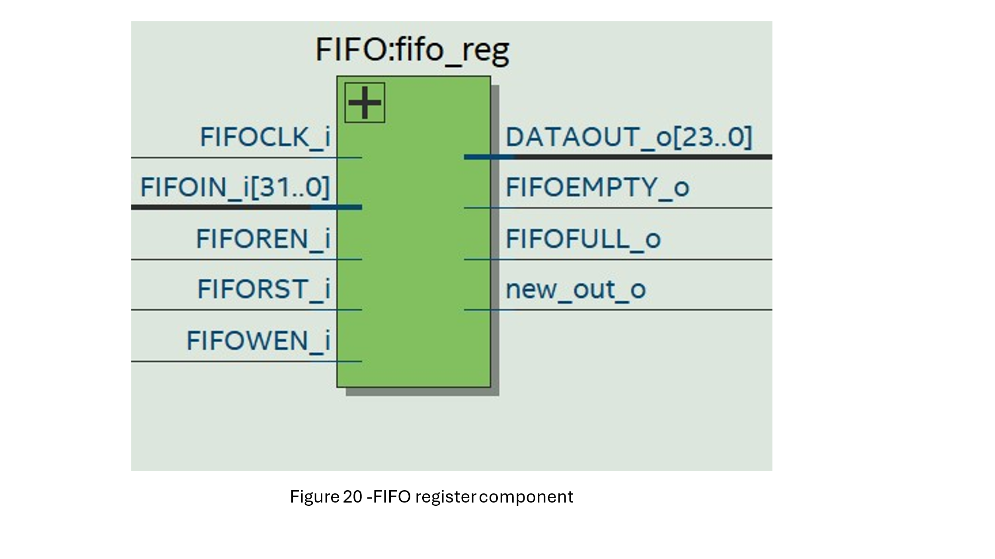

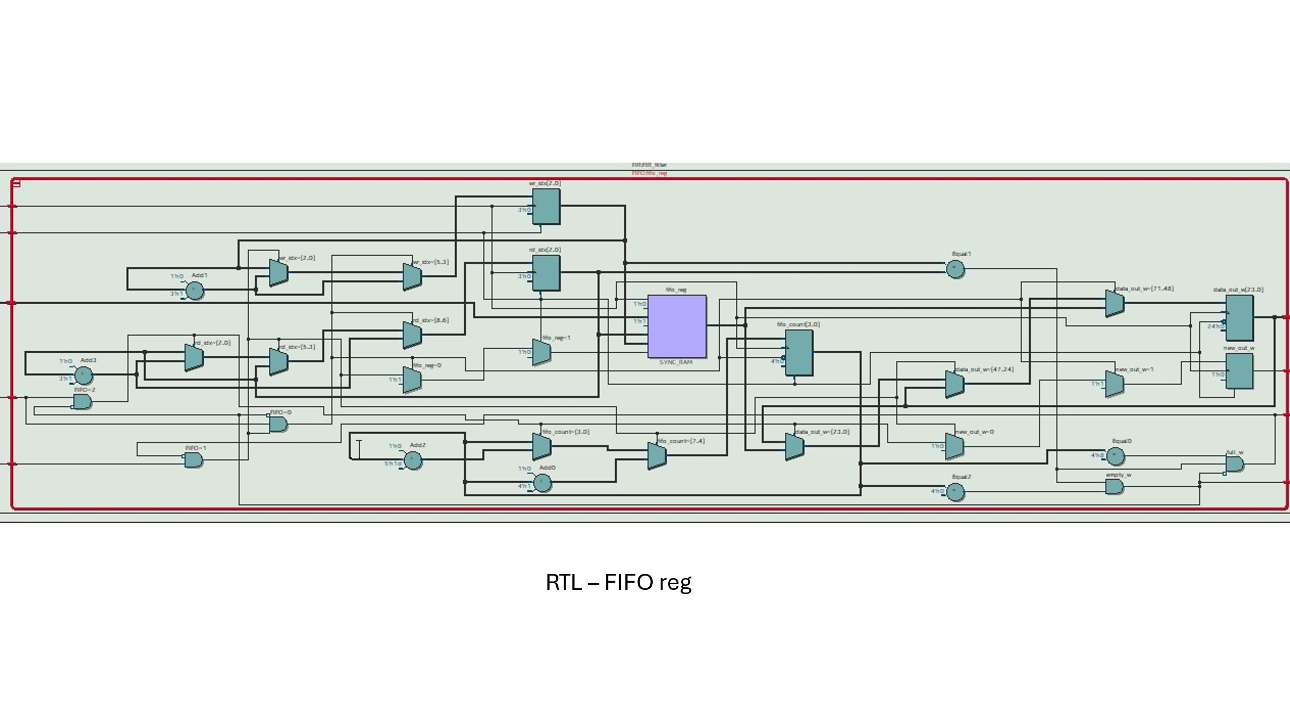

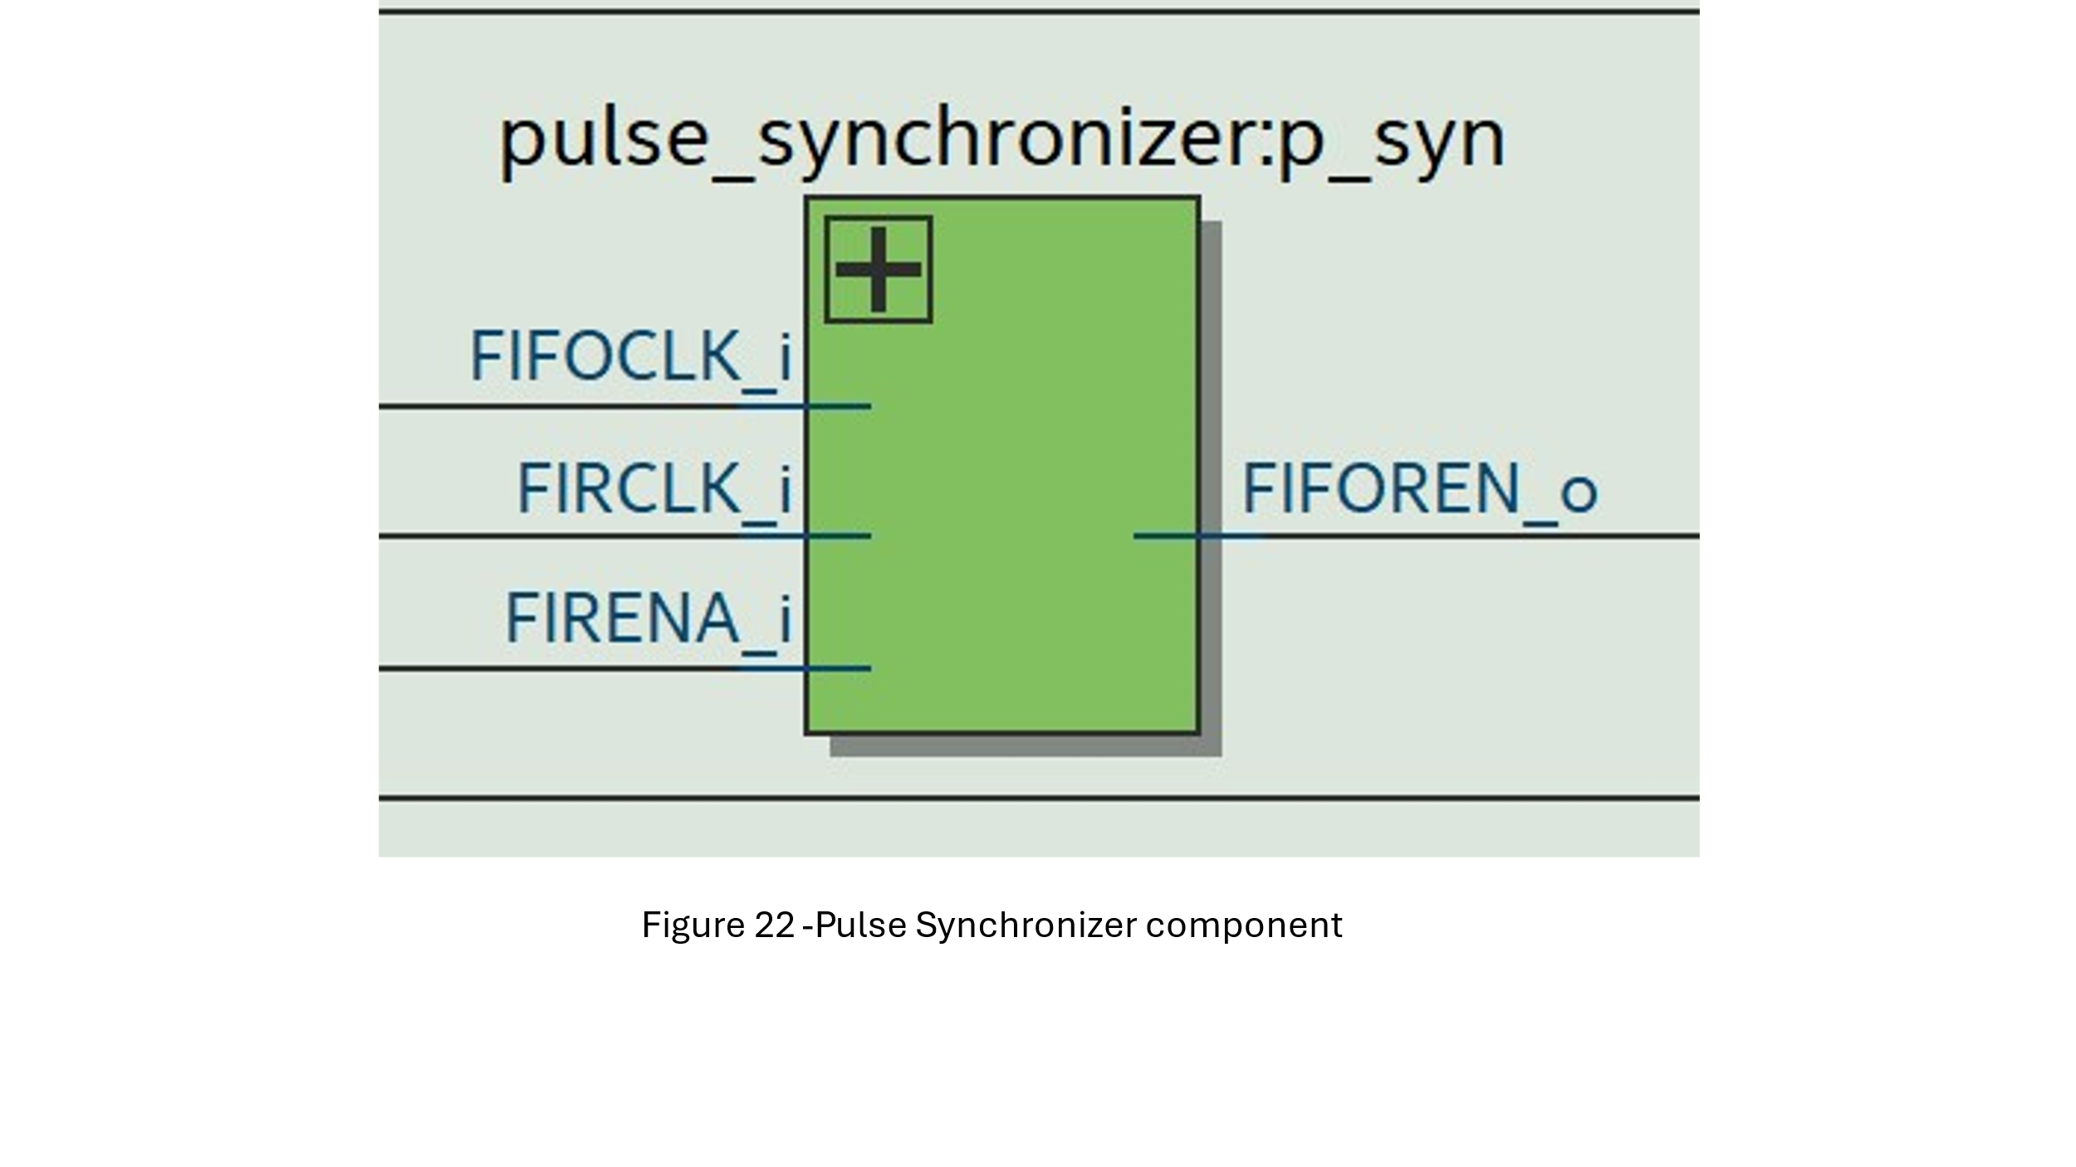

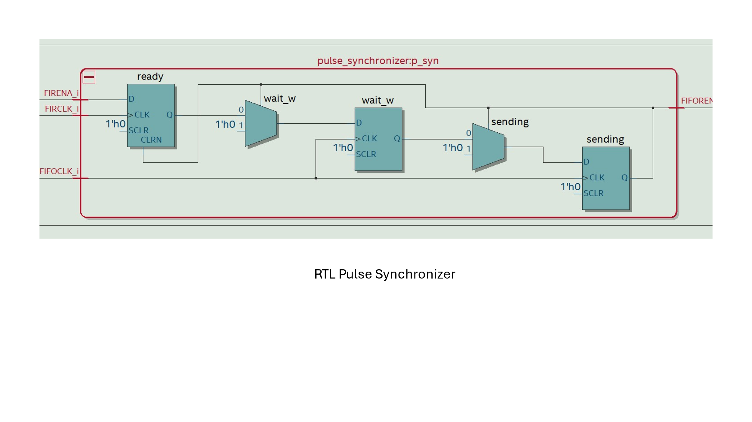

We tried to implement as described in the mission (with some changes)

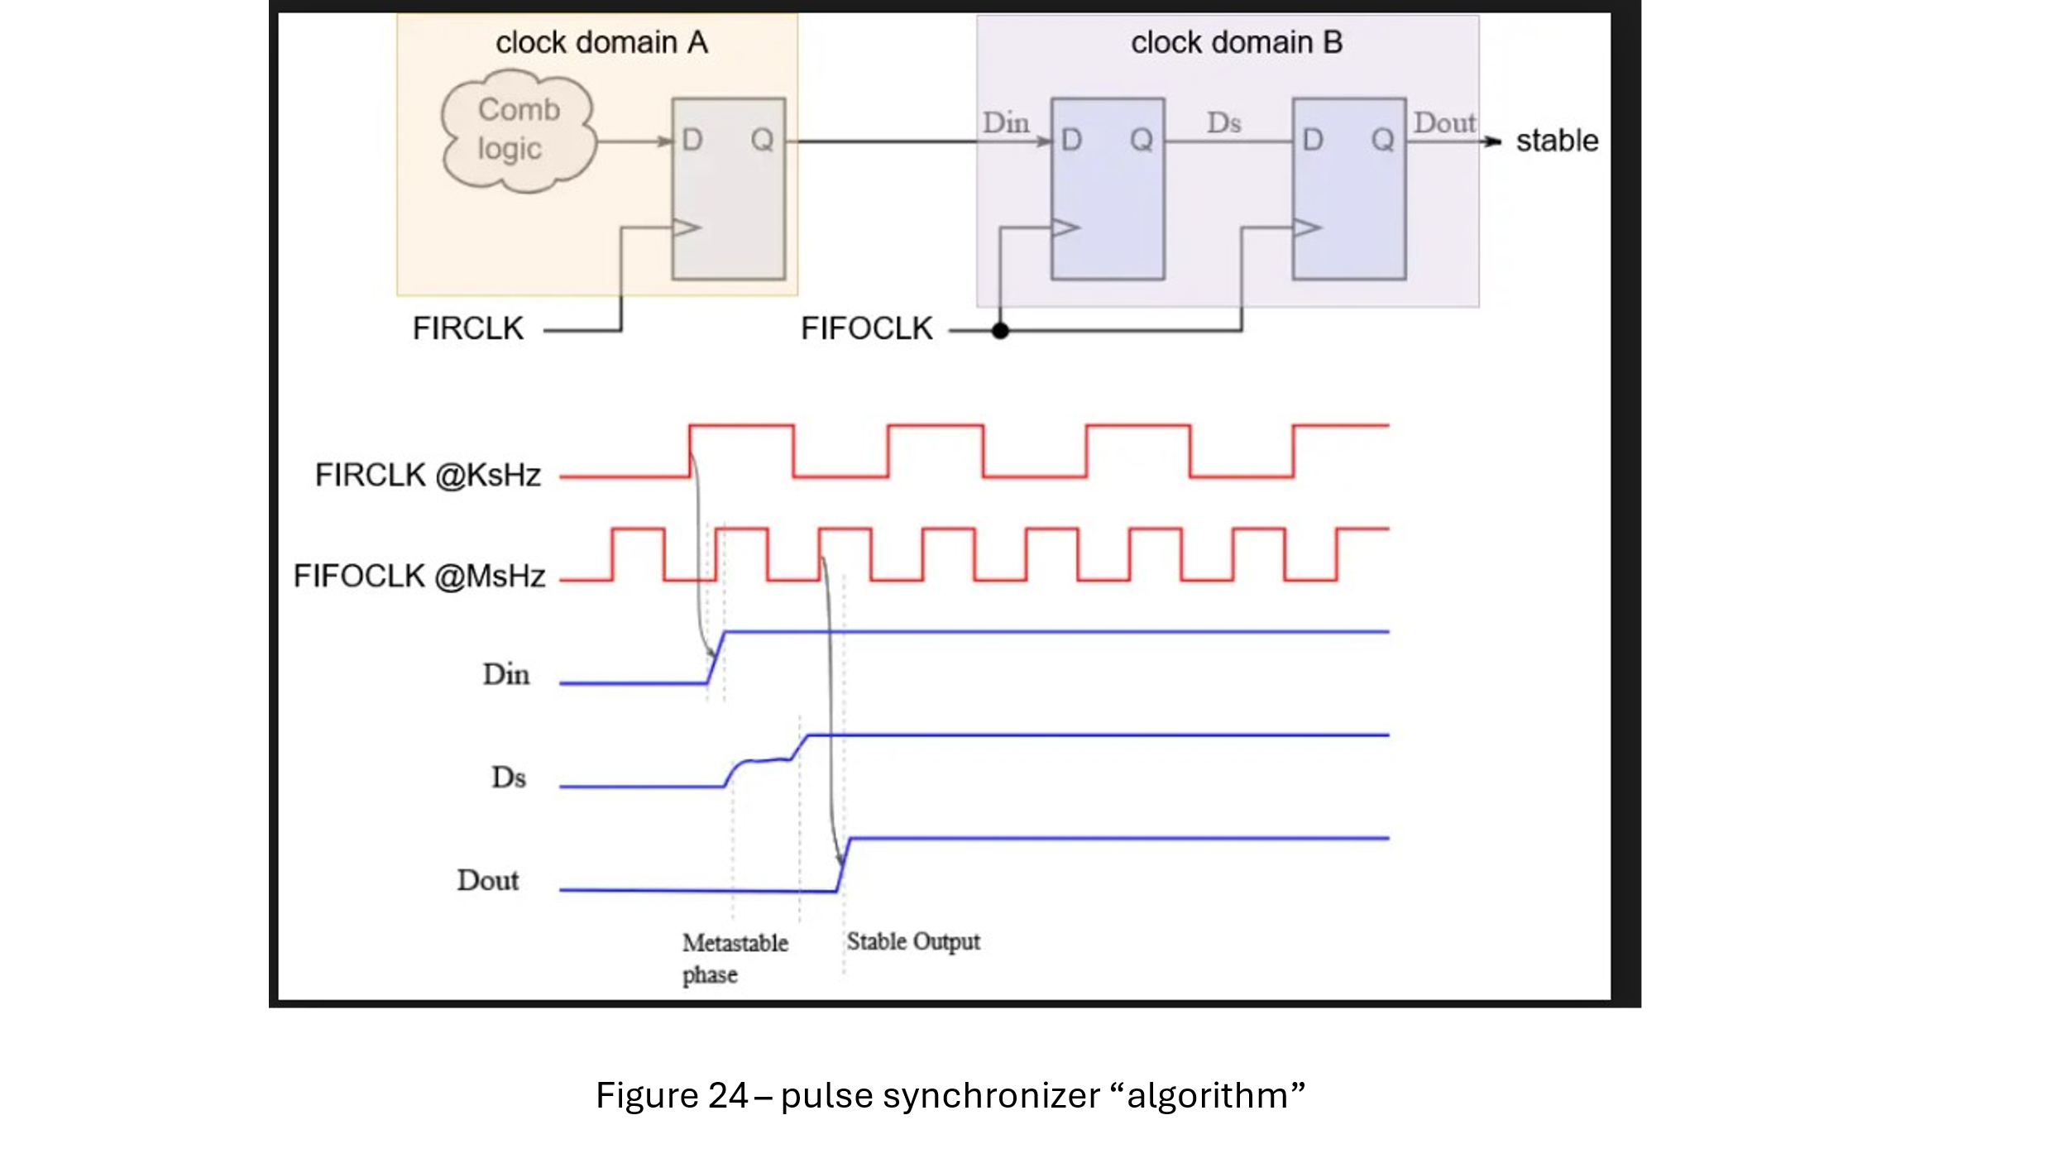

**Interrupt controller:**

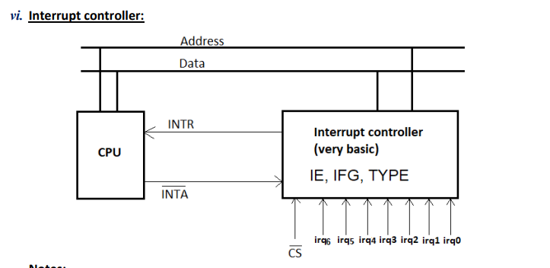

When there is an interrupt and the user allows it (GIE = ‘1’) the interrupt controller will send INTR = ‘1’ when an interrupt have been captured (depending on IE value).

Then if the MIPS is available to handle the interrupt (currently not handling another interrupt) it will send INTA = ‘0’ (acknolage).

The next step is that the interrupt controller will send the type of the interrupt that have been chosen by the highest priority algorithm.

In addition, the interrupt controller will send the enable register and the flag register according to the requirement (user read from its memory address).

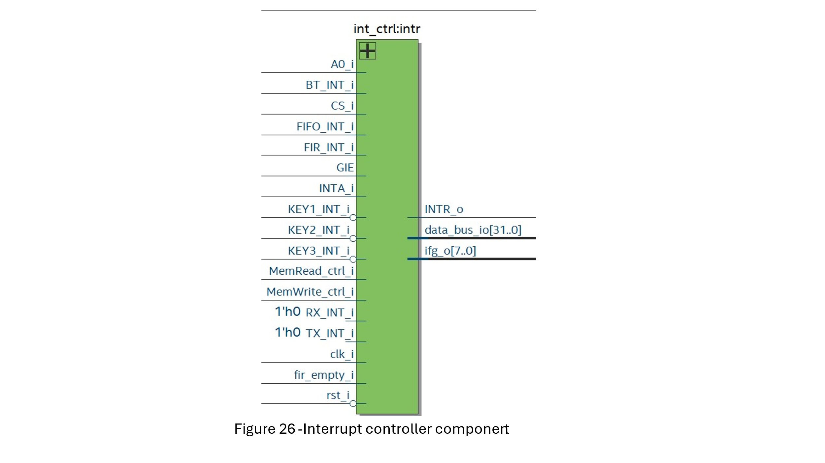

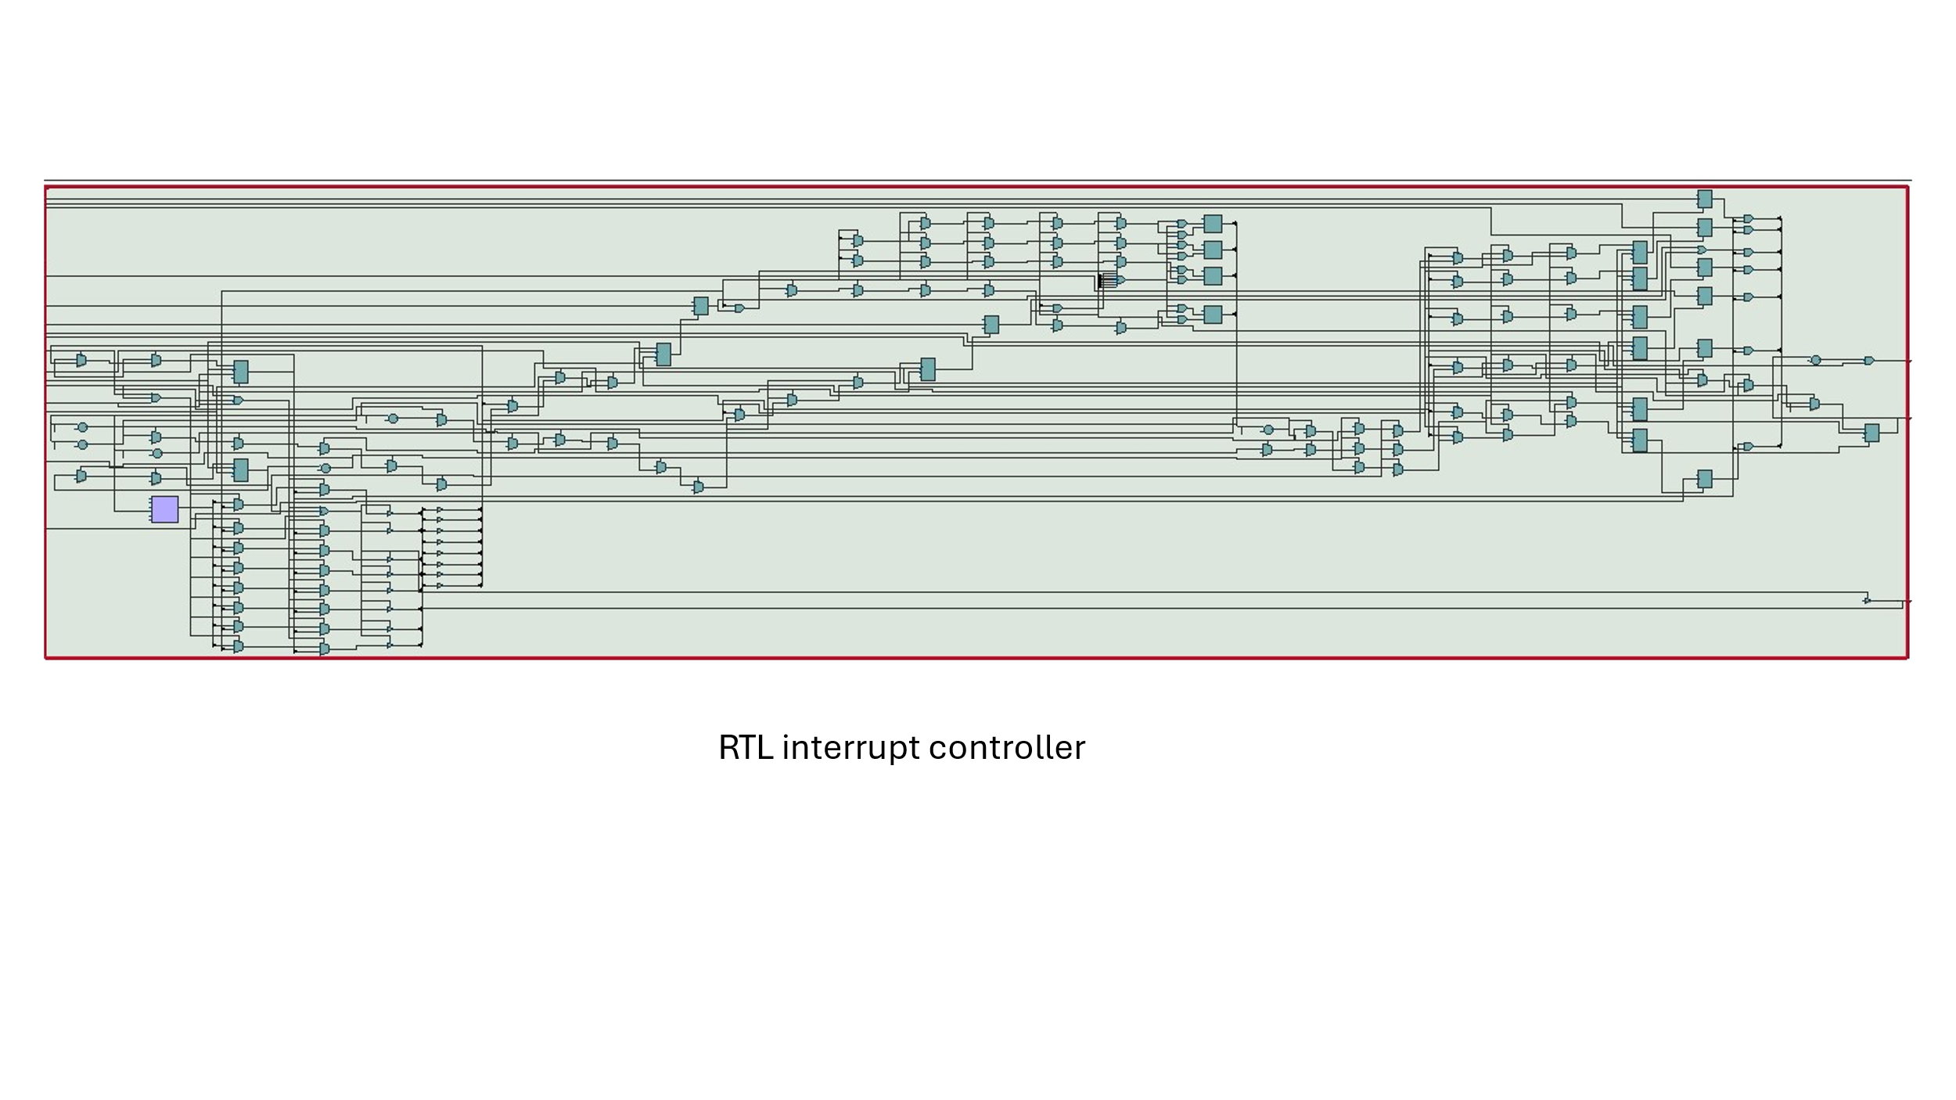

**RTL of all the MCU:**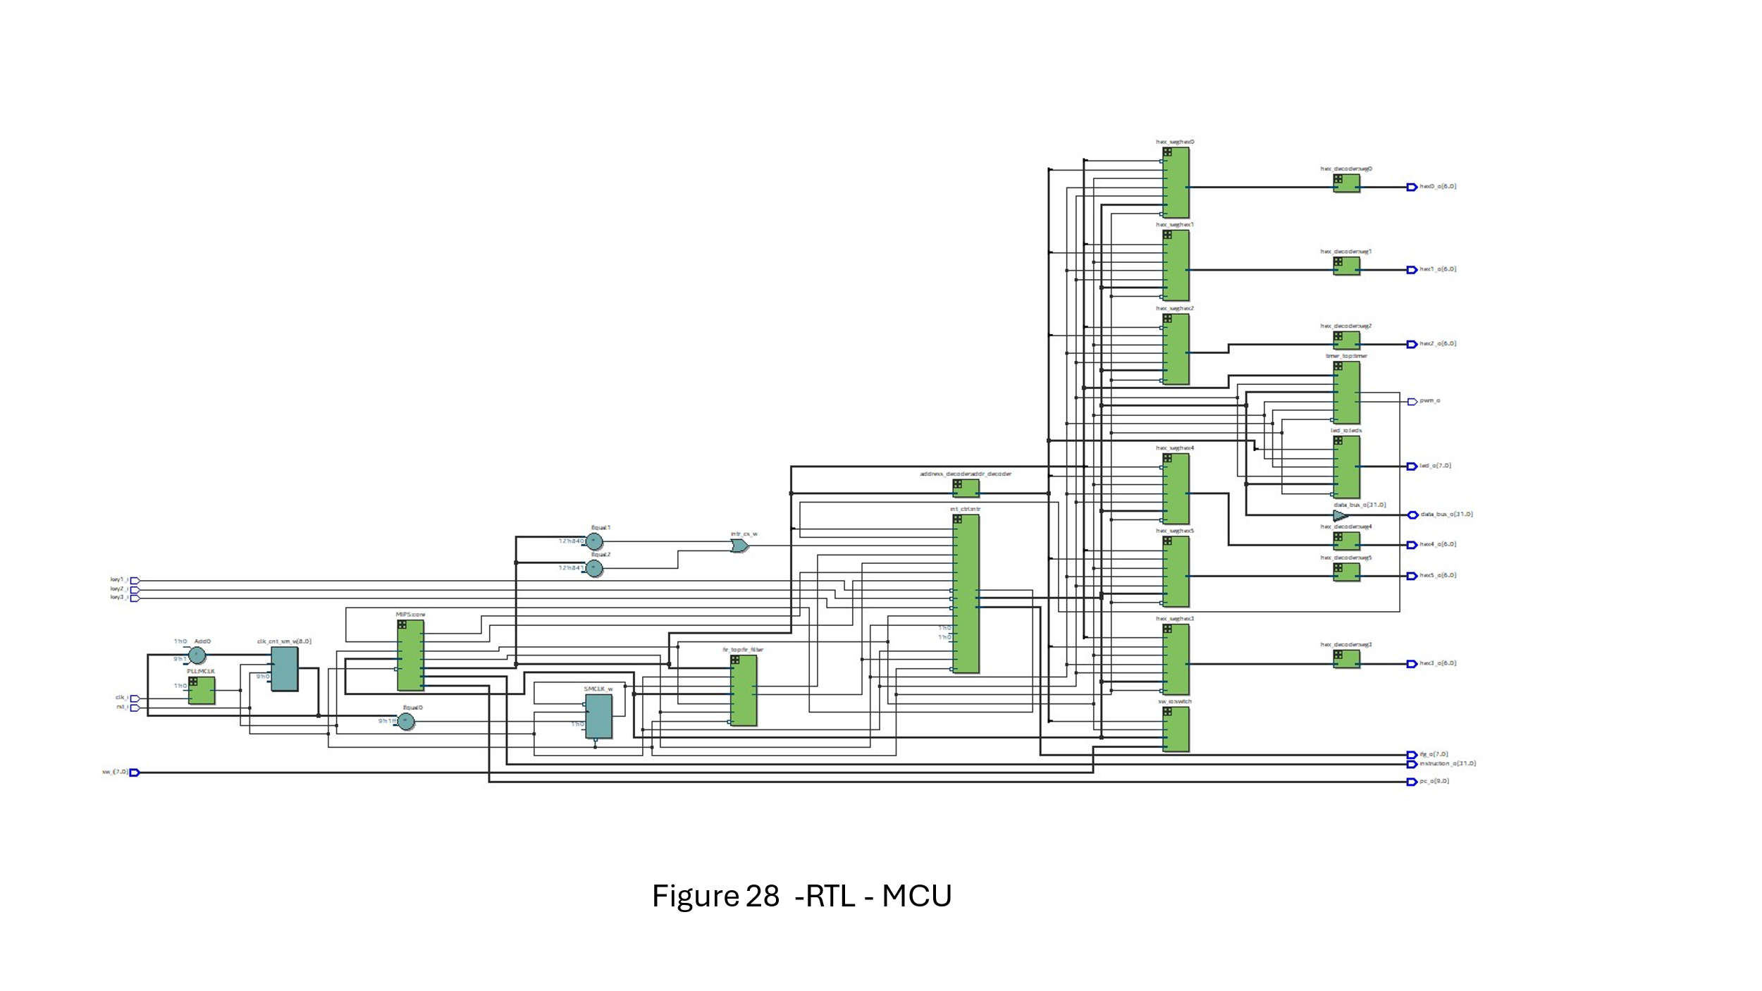

**Critical Path:**Our critical path is the longest path for the expansion of the data – its the slowest path of our system.

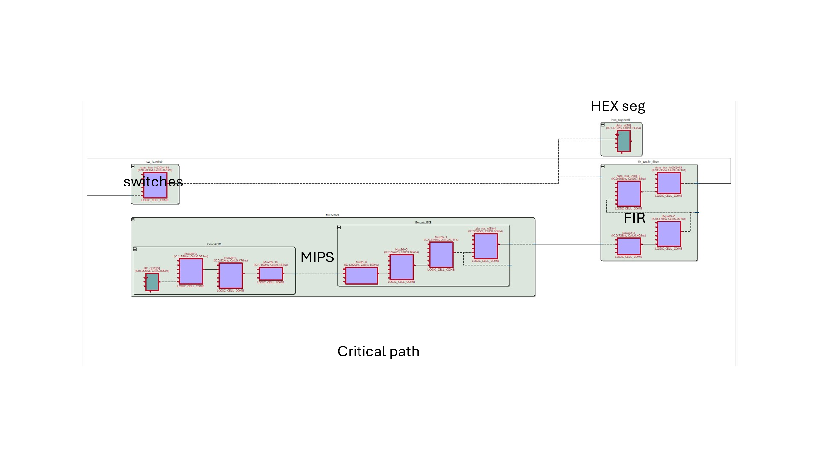

And this is Fmax:

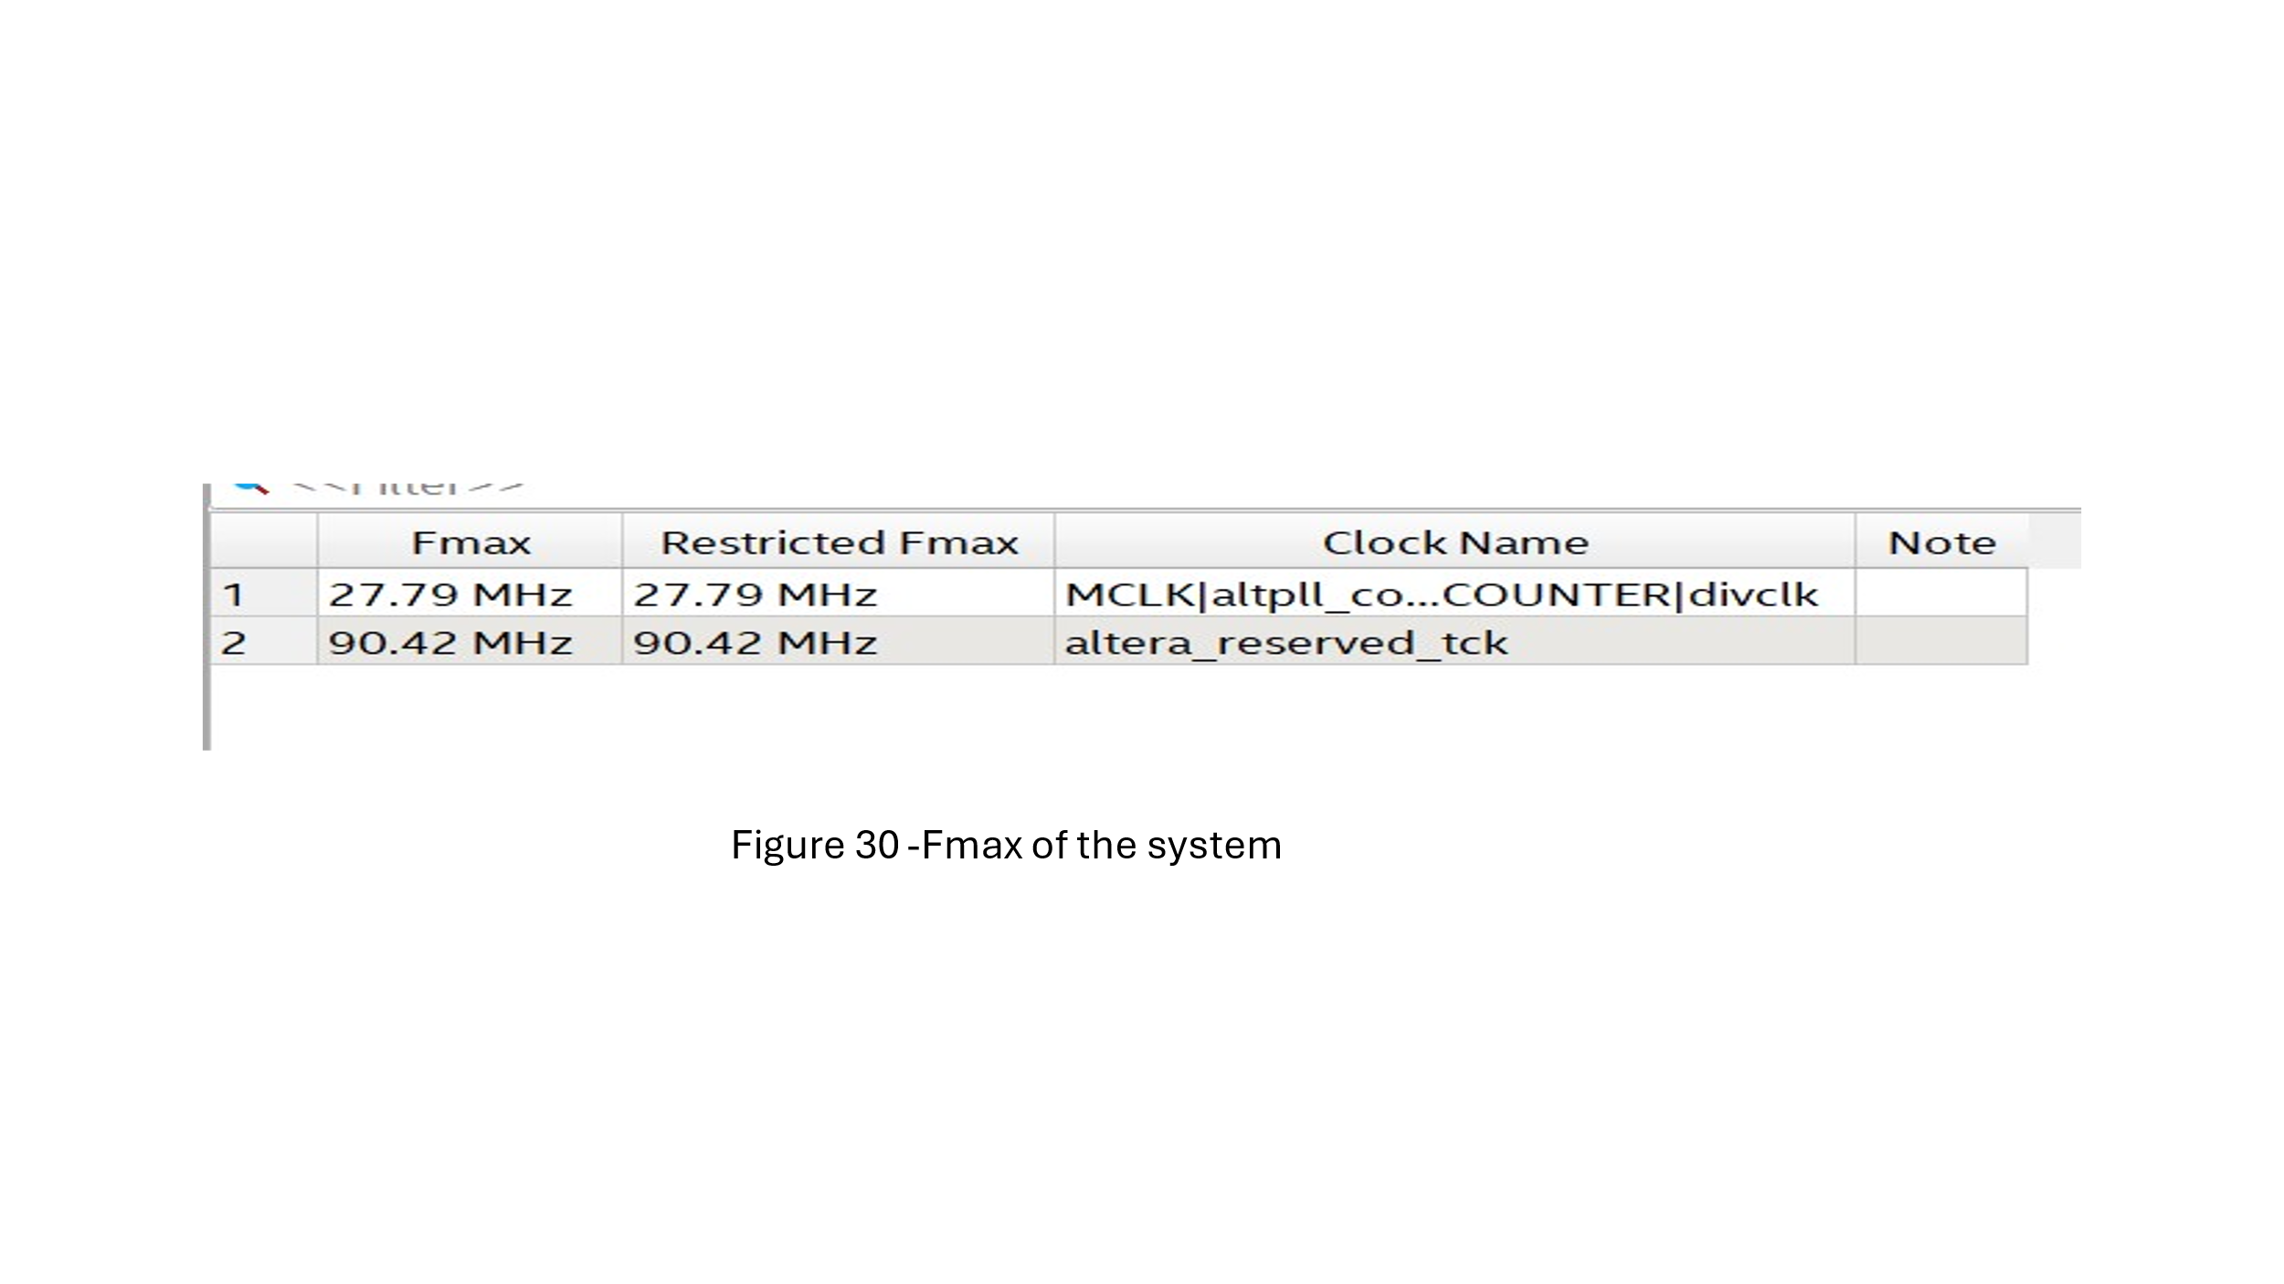

**Test our system:**

This is an example of test 1 :  
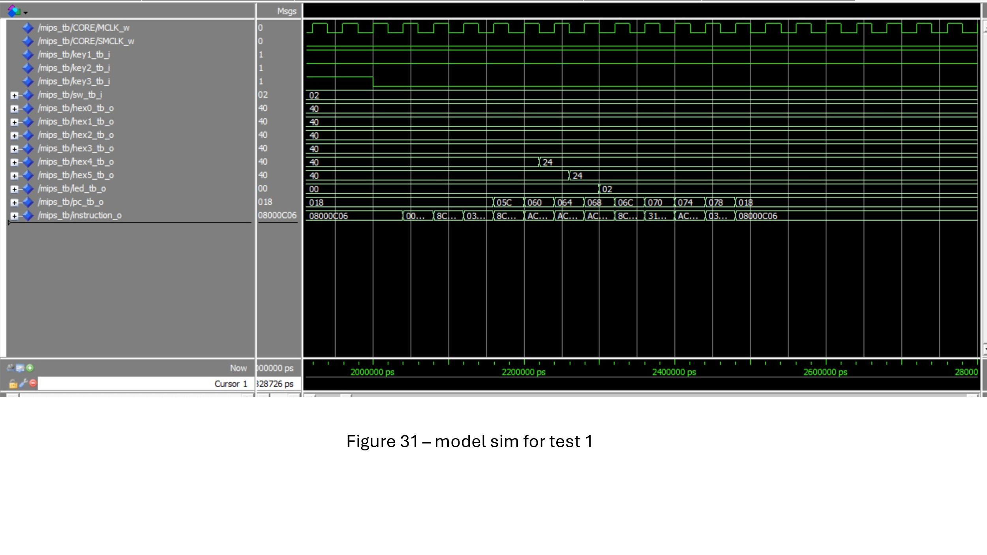here we can see the interrupt.

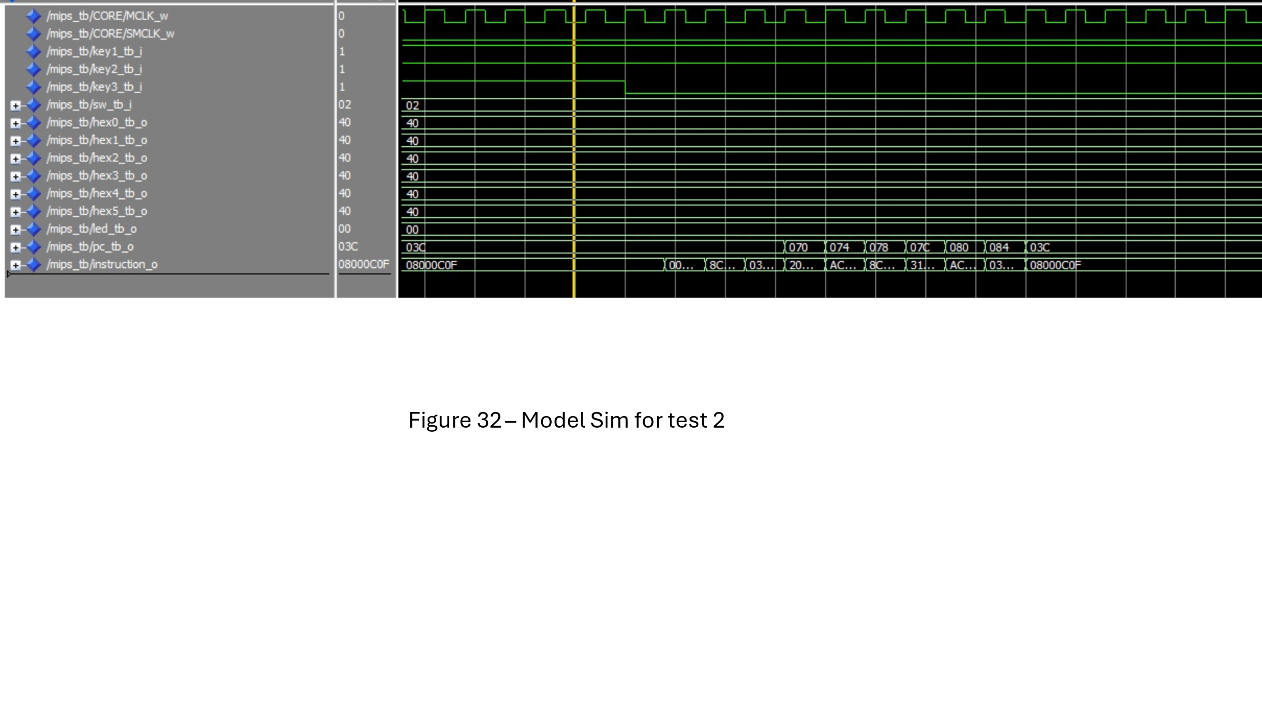

Again an example for one of the interrupts.

